**Project Template**

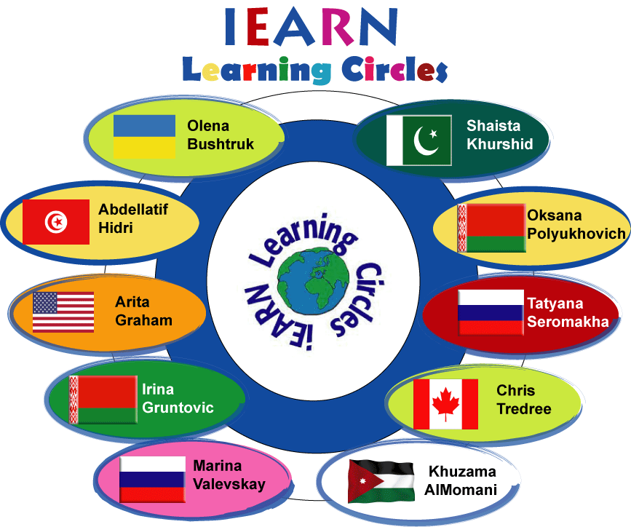

**Submitted By: Shaista Khurshid**

**28th October,2013**

**C:\Users\Shaista Khurshid\AppData\Local\Microsoft\Windows\Temporary Internet Files\Content.IE5\Q4YT3PYG\MC900115918[1].wmf**

**Learning Circle Group:**

Computer Chronicles Learning Circle 1 (Middle School)

**Sponsoring Teacher:**

Shaista Khurshid  
**Sponsor School:**

Beaconhouse School System-Jubilee Campus  
**City:**

Karachi  
**Country:**

Pakistan  
**Name of Project:**

Healthy Recipes from My Kitchen

**Goal Of The Project**:

Create a customized meal plan that is balanced with the right amount of servings from each of the food groups and within their caloric requirements.

**Type Of Writing Requested:**

Instructions (For recipes) and Informational/Persuasive for articles

**Description Of What You Are Looking For From Other Schools:**

**Questions:**

* What is healthy food?
* What are the essential components of food?
* How many components of food you can recognize in your daily meals?
* What is a balanced diet? Why there is a need for one?
* How can you plan a balanced and healthy platter for you?

**Story Prompts:**

* Research about healthy food and essential components of food.
* What make a meal a balanced and healthy?
* Investigate how will you create a healthy platter for yourself?
* What instructions /guidelines will you use to prepare healthy meal?
* Why is it important to have healthy food?

**Detailed Instructions For Collecting Information:**

**Step-I :** Reading and investigation about healthy food and balanced diet.

* Let children explore with reading, hands on activity and discussion about the major components of food and why they are essential for growth and development.
* Let them plan their healthy platter (using internet, sites are given in the project idea.

**Step-II:** Implementation /application-Preparation of healthy food

* Now it’s time to be creative, let students prepare one meal for themselves in groups/pairs and write instructions for it. Instructions should include:

i. Meal Selected (Breakfast, Lunch, Supper, Tea time, Dinner)

i. Ingredients (What is required? quantity, measurements etc)

ii. Method/Procedure (Detailed instructions, how to cook/Prepare)

**Ideal Number Of Submissions From Each School:**

* Two recipes (Instructional Writing)
* Two articles(Informational/Persuasive Writing)
* Short articles about the importance of healthy/Balanced diet.

**Preferred Length Of Articles:**

* 150-200 words

**Deadline For Receiving Information (Circle deadline is December 8, 2013):**

* 15th -20th November

C:\Users\Shaista Khurshid\AppData\Local\Microsoft\Windows\Temporary Internet Files\Content.IE5\A4M7L9KZ\MC900104718[1].wmf

Good luck! Feel free to ask questions

Detailed instructions are given in the project idea already submitted in the forum.